Charlotte ISD Special Board Meeting

February 13, 2024 at 6:30 p.m. in the 41 Rose Blvd. Bldg O

- Call to Order
- Pledge of Allegiance
- Moment of Silence
- Invocation
- Public Comments
- Superintendent Report
- Consider and take possible action to approve the consultant agreement with Walker Quality Services
- Executive Session/Closed Session, Section 551.072 For the purpose of deliberation regarding the purchase, exchange, lease, or value of real property
- Executive Session/Closed Session Pursuant to Texas Gov't code 551.074, For the purpose of discussing and consider Administrators Contract.
- Pursuant to Section 551.071 of the Texas Government Code, consultation with the District’s attorney concerning legal issues related to a bond election
- Open Session
- Consideration and approval of an order calling a bond election to be held by the Charlotte independent School District, making provision for the conduct of a joint election, and resolving other matters incident and related to such election
- Consider and take possible action on approval of resolution authorizing purchase of property located at 408 Jourdanton Ave. Charlotte, Texas in Atascosa County, Texas.
- Consider and take possible action on Administrator Contracts.
- Adjourn

If, during the course of the meeting, a discussion of any item on the agenda should be held in a closed meeting, the board will conduct a closed meeting in accordance with the Texas Open Meetings Act, Texas Government Code, Chapter 551, Subchapters D and E or Texas Government Code section 418.183(f). Before any closed meeting is convened, the presiding officer will publicly identify the section or sections of the Act authorizing the closed meeting. Including:
Section 551.071 For the purpose of a private consultation with the Board&rsquo;s attorney.
Section 551.072 For the purpose of discussing the purchase, exchange, lease, or value of real property and negotiated contracts for prospective gifts or donations.
Section 551.074 For the purpose of considering the appointment, employment, evaluation, reassignment, duties, discipline, or dismissal of a public officer or employee or to hear complaints or charges against a public officer or employee.
Section 551.082 For the purpose of considering discipline of a public school child or children.
Section 551.076 To consider the deployment, or specific occasions for implementation, of security personnel or devices.
Section 551.083 For the purpose of considering the standards, guidelines, terms or conditions the Board will follow or will instruct its representatives to follow, in consultation with representatives of employee groups in connection with consultation agreements provided for by Texas Government Code Chapter 551.
Section 551.084 Excluding witnesses from a hearing

All final votes, actions, or decisions will be taken in open meeting. [See BEC (LEGAL)]

This notice was posted in compliance with the Texas Open Meetings Act on Thursday February 8, 2024 at 4:00p.m.

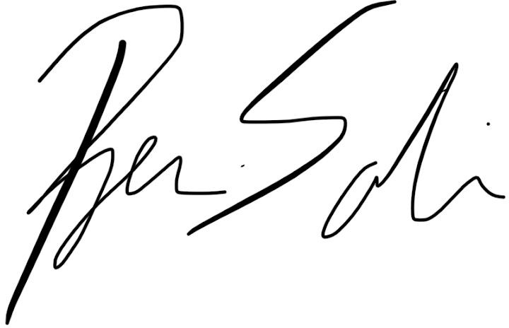
For the Board of Trustees

